The Curious Case of Sports in Saudi Arabia

[1]

Saudi Arabia is revolutionizing its sports landscape, aligning with Saudi Vision 2030 to become a global force in sports entertainment space. The Kingdom's commitment to sports sector development is evident in the strategic high-profile sports events they have hosted in the recent past including the likes of Esports World Cup, Diriyah Eprix, WTA Tennis Finals. Moreover, SPL is growing rapidly, so much so, that the Kingdom is gearing up to host the FIFA World Cup 2034.[2]

Saudi Arabia’s demography is the backbone of the sports industry. Approximately 40% of the population is below 25 years of age[3], and the median age of the population is 29 years[4]. Sports fans are high in number, and this age demographic attracts a lot of sports traction within the country. Saudi wants to quench this thirst for sports (and entertainment) within the country by making it a global sports destination, which will also attract global talent and tourists to visit Saudi for sports tournaments in the coming decades.

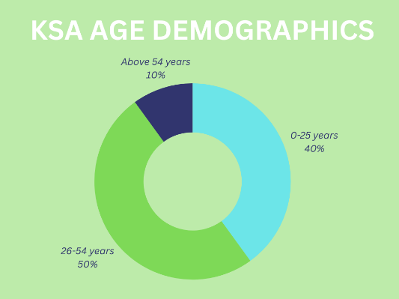

The Saudi government's strategic investments in sports infrastructure projects are creating unprecedented opportunities for workforce planning and talent acquisition. High-profile partnerships, such as WWE's decade-long contract and the successful bid to host the 2034 FIFA World Cup, underscore the Kingdom's ambition in mega-sporting events. The sports events industry alone has grown at a CAGR of 8% from 2018 to 2024.

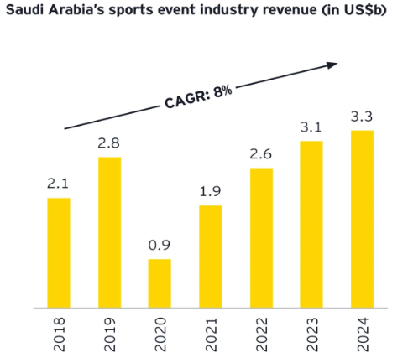[5]

The Saudi Pro League, now boasting international stars like Ronaldo, Neymar, and Benzema, exemplifies the country's sports marketing prowess. With a projected market value of eight billion riyals by 2030, it is attracting significant private-sector investment. This growth, coupled with the fact that 80% of Saudis engage with football, presents enormous potential for sports business administration and fan engagement specialists.

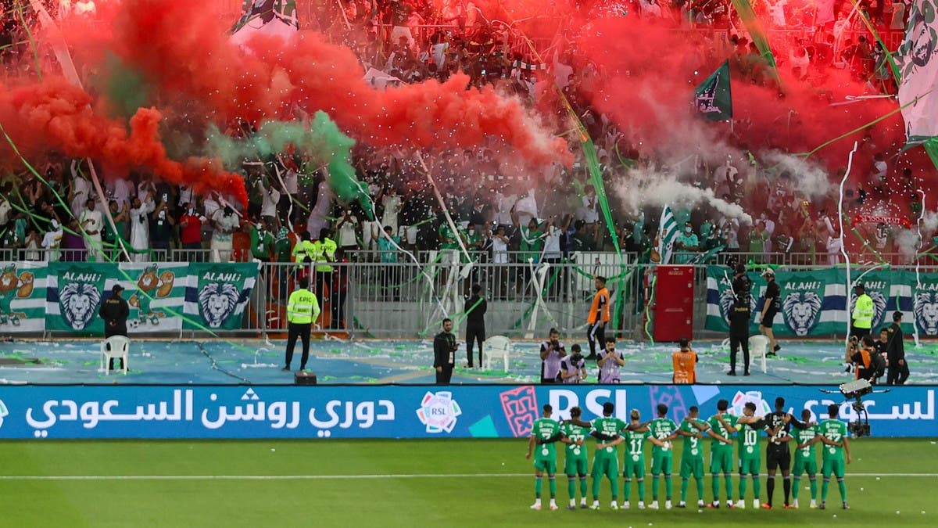[6]

A global proximity advantage which Saudi Arabia finds itself in, is that it is centrally located in the Middle East, which makes it just a five-hour flight for over 1.5 billion people. Based on convenience for tourists, this is ideal for the government. The Ministry of Sports is positioning Saudi as a prime sports hub which has a ripple effect on sports tourism, creating diverse opportunities in hospitality for sports events. A sports events attendant usually combines their engagement in the sport with local tourism, giving birth to a synergy among sports, entertainment, tourism, and hospitality.

To not let this go to waste, the government is taking massive steps. One solid example remains the introduction of e-visas for tourists ahead of Formula E in 2018. Ever since, they have hosted over eighty international sports events, and they have drawn in over three million attendees on e-visas in just five years.

Another big market is sports infrastructure. The development of infrastructure is in full swing, with a new Olympic village under construction in Riyadh and similar projects in Dammam, Jeddah, and Abha. Not only this, after winning the bid to host FIFA World Cup 2034, Saudi Arabia has announced major stadium construction projects across the country which will boost the already galloping EPC market. These multi-million-dollar ventures encompass various facilities, stimulating demand across multiple sectors.

For companies looking to establish a presence in Saudi Arabia, the current market conditions are highly favourable. However, navigating compliance challenges such as company incorporation, registering with multiple government portals, and legalization requires expertise and experience of someone already in the Kingdom.

On the other hand, for companies already in Saudi looking to expand and hire relevant resources, faster; they must deal with global mobility, immigration, Saudization, and other such processes.

At TASC Outsourcing, we have been working day in and day out with some of the biggest companies: helping them set up operations and expand for over 17 years. We offer comprehensive solutions to address challenges. Our services span from office setup to managing Iqamas for employees, from handling GRO to contract staffing, and from global mobility to payroll services; ensuring seamless integration into the Saudi market while you focus on leveraging the booming industry for your business growth.

1. [The Economist | Saudi Arabia is Spending a Fortune on Sports](https://www.economist.com/briefing/2023/08/10/saudi-arabia-is-spending-a-fortune-on-sport)
2. [Shourya Arora on LinkedIn | The Curious Case of Sports in Saudi Arabia](https://www.linkedin.com/feed/update/urn:li:activity:7231554892492902400/)
3. [KSA Population Statistics 2024](https://www.globalmediainsight.com/blog/saudi-arabia-population-statistics/)
4. [Reuters | Saudi Population Census](https://www.reuters.com/world/middle-east/saudi-population-322-mln-median-age-29-years-old-general-authority-statistics-2023-05-31/)
5. [EY | How Sports Events can transform the Saudi Arabian Economy](https://www.ey.com/en_pk/services/consulting/how-sports-events-can-transform-the-saudi-arabian-economy)
6. [AlArabia News | New Era for Saudi Pro League](https://english.alarabiya.net/News/saudi-arabia/2023/09/21/New-era-for-Saudi-Pro-League-sees-unprecedented-growth-global-fan-engagement)